1.Deploy the custom image with any application installed.

In a vm I have installed the application chrome.

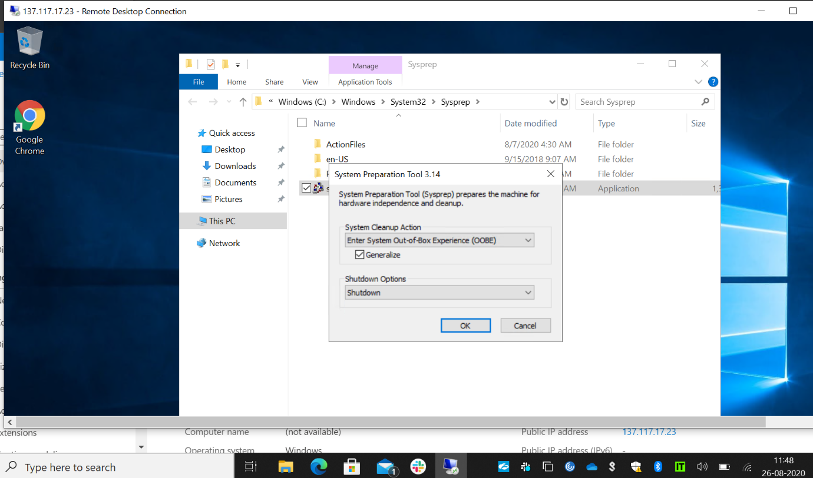

Generalized that application and shutdown the vm.

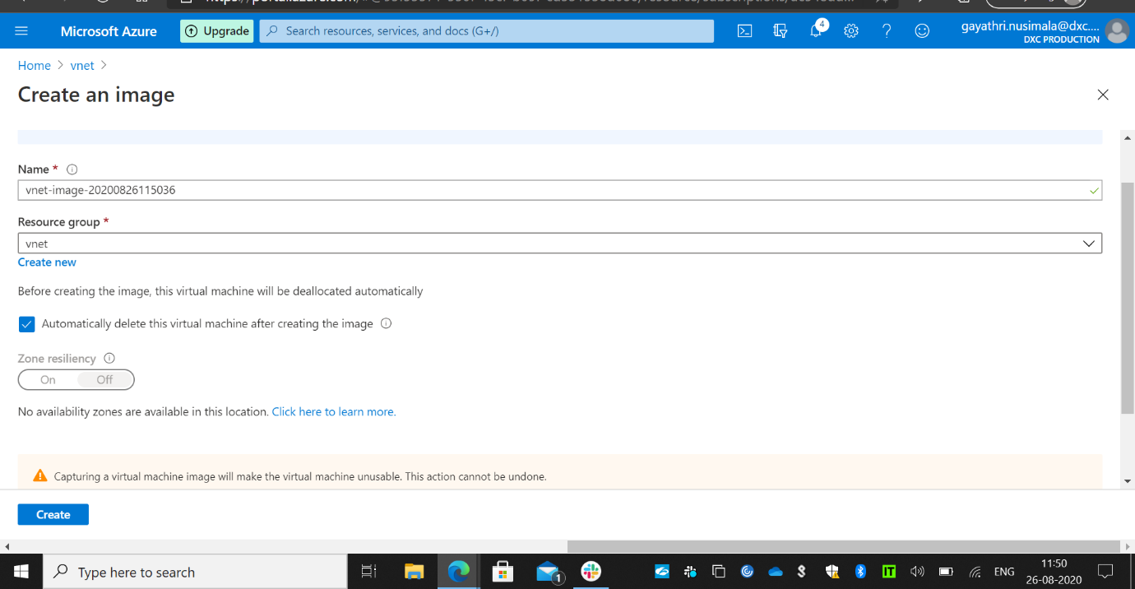

Created an image which I have installed and generalized in the vm.

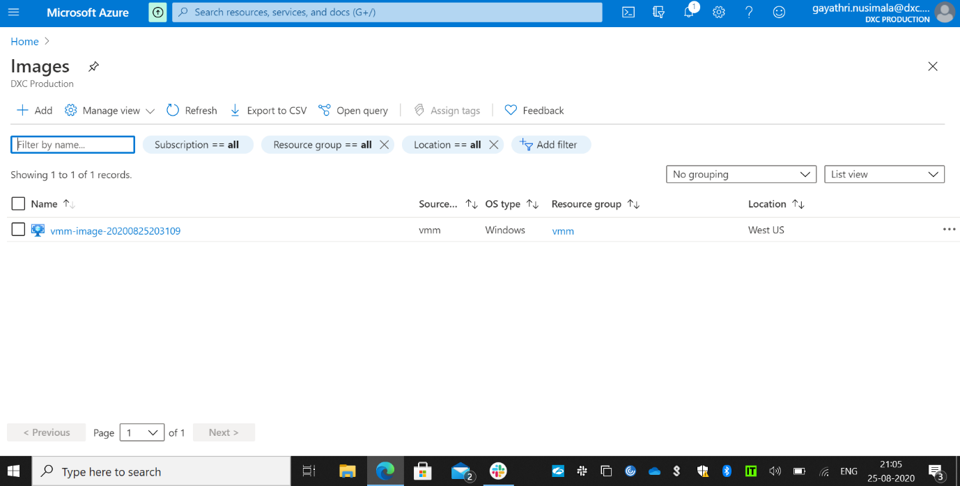

Here is the image created.

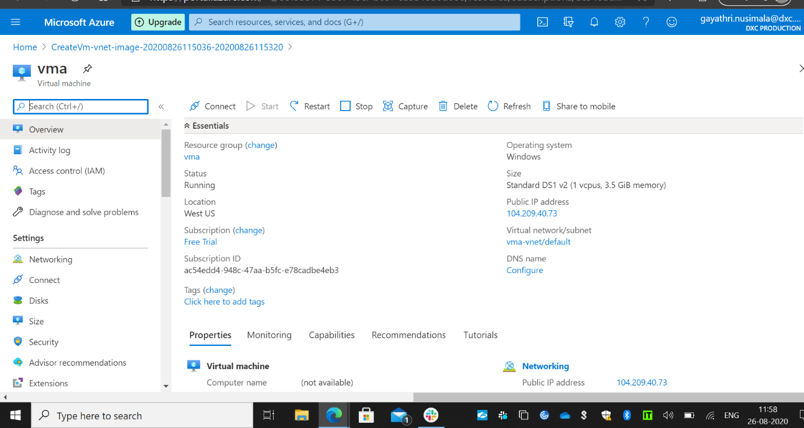

Created a vm with the image deployed in it.

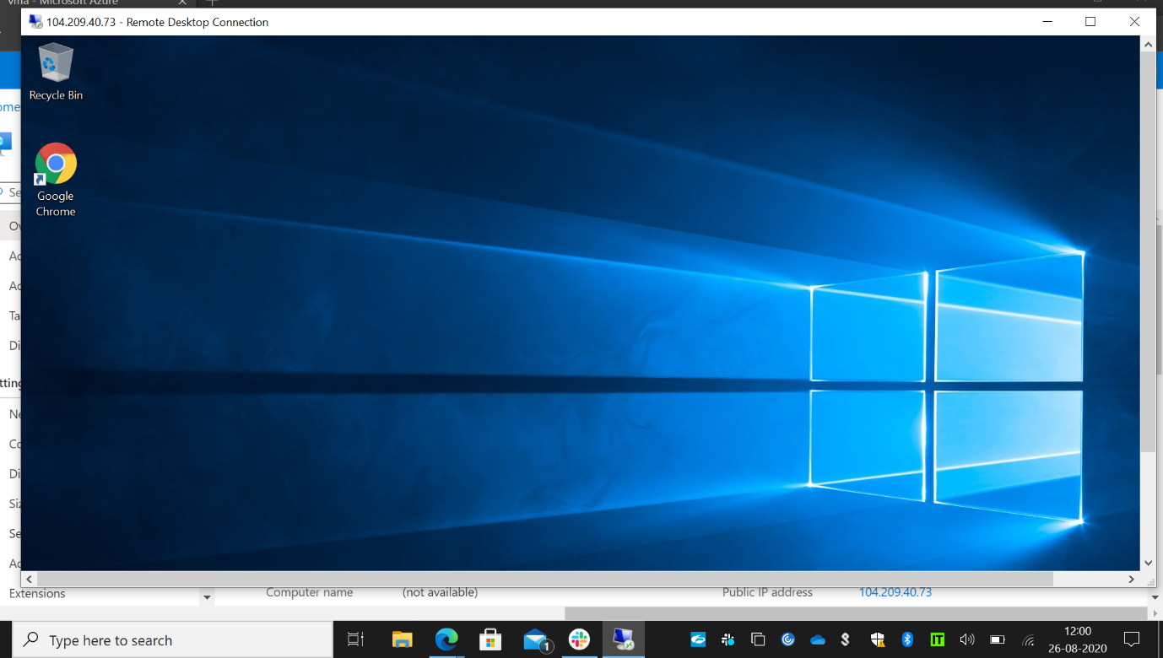

Here the image deployed in the vm that we have created.

2. Create a two networks in East Asia and west us and peer the network using Network

Peering and access the VM using private from one location to other location.

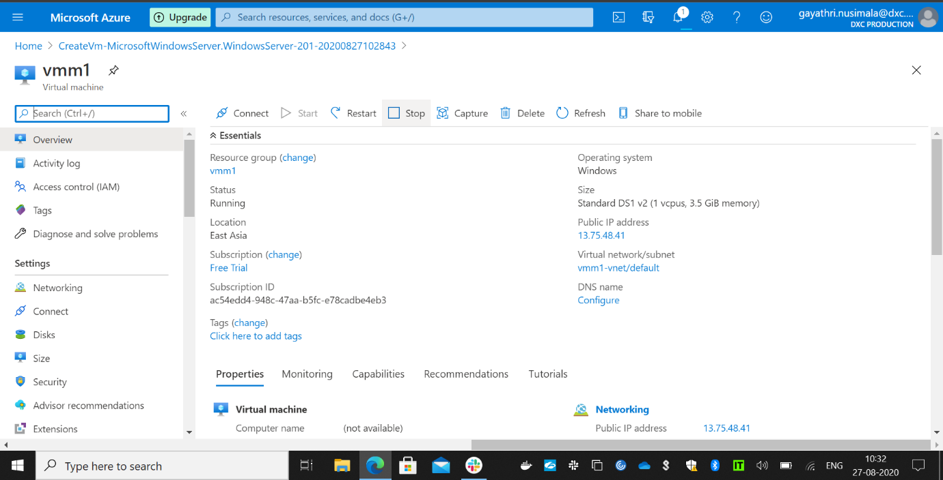

Created a vm in East Asia.

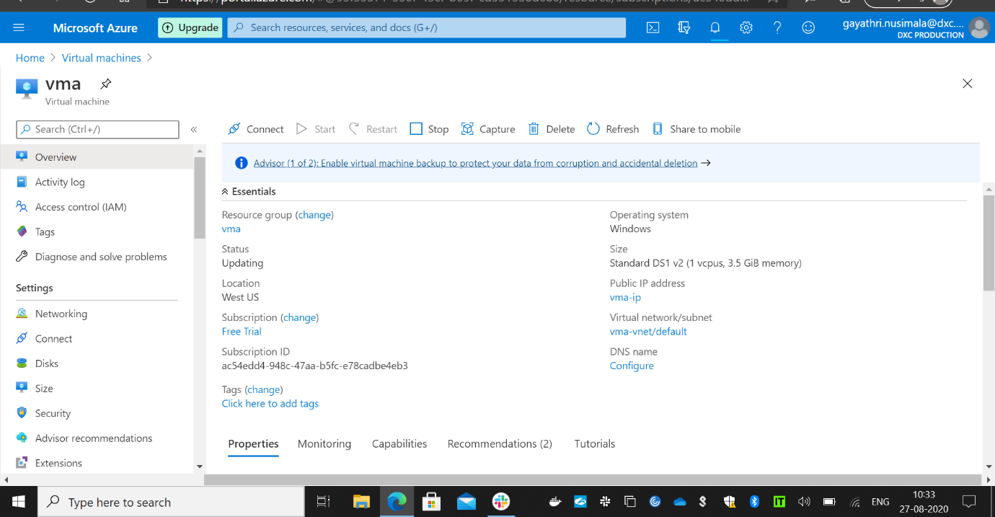

Created vm in West US.

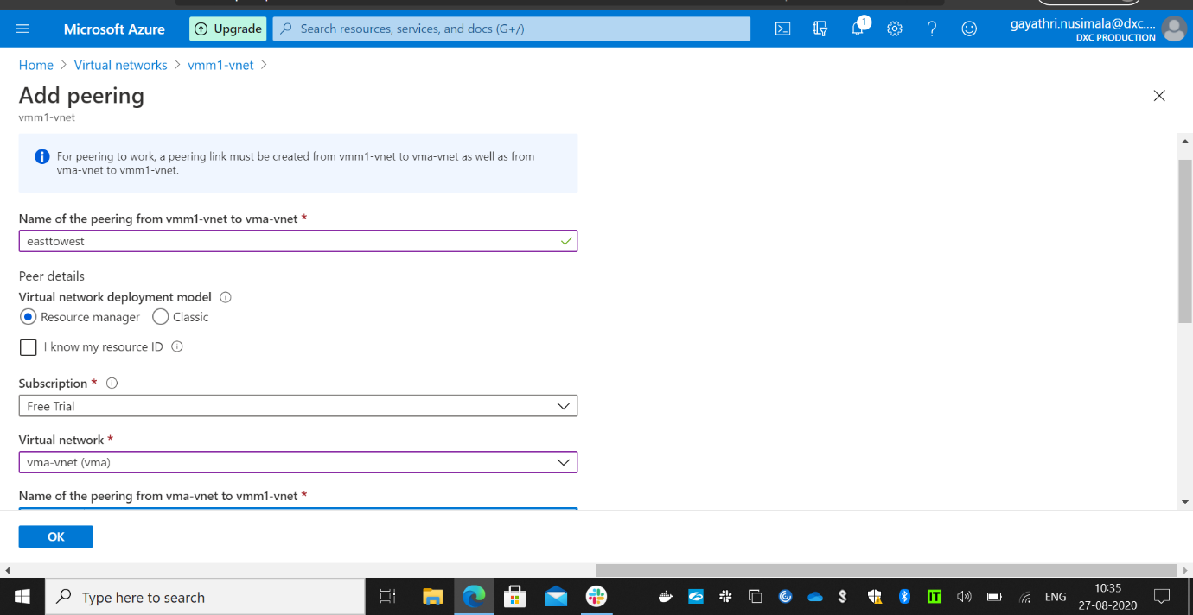

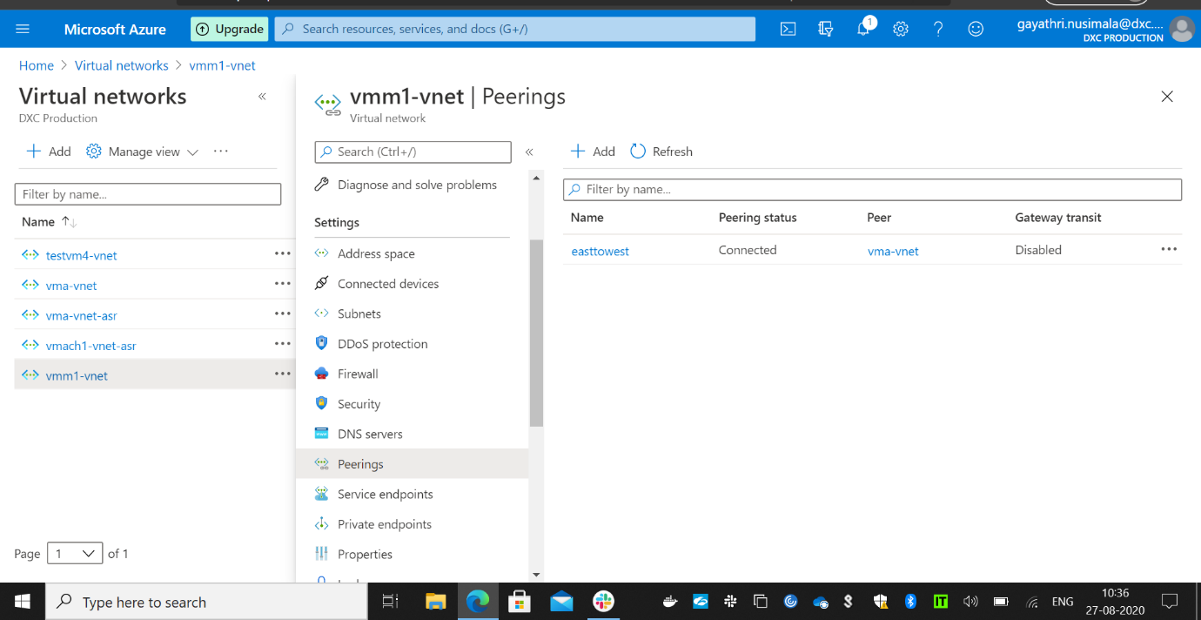

Created peering between the to networks.

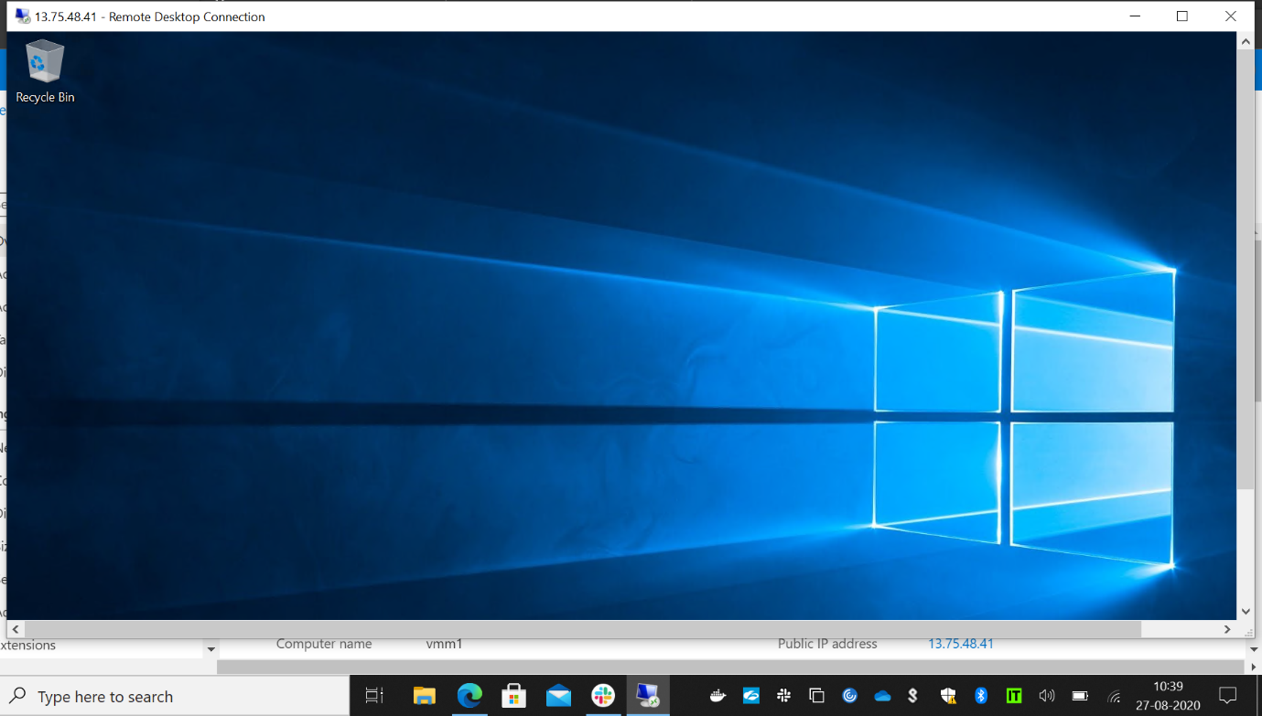

Opened vm which in East Asia .

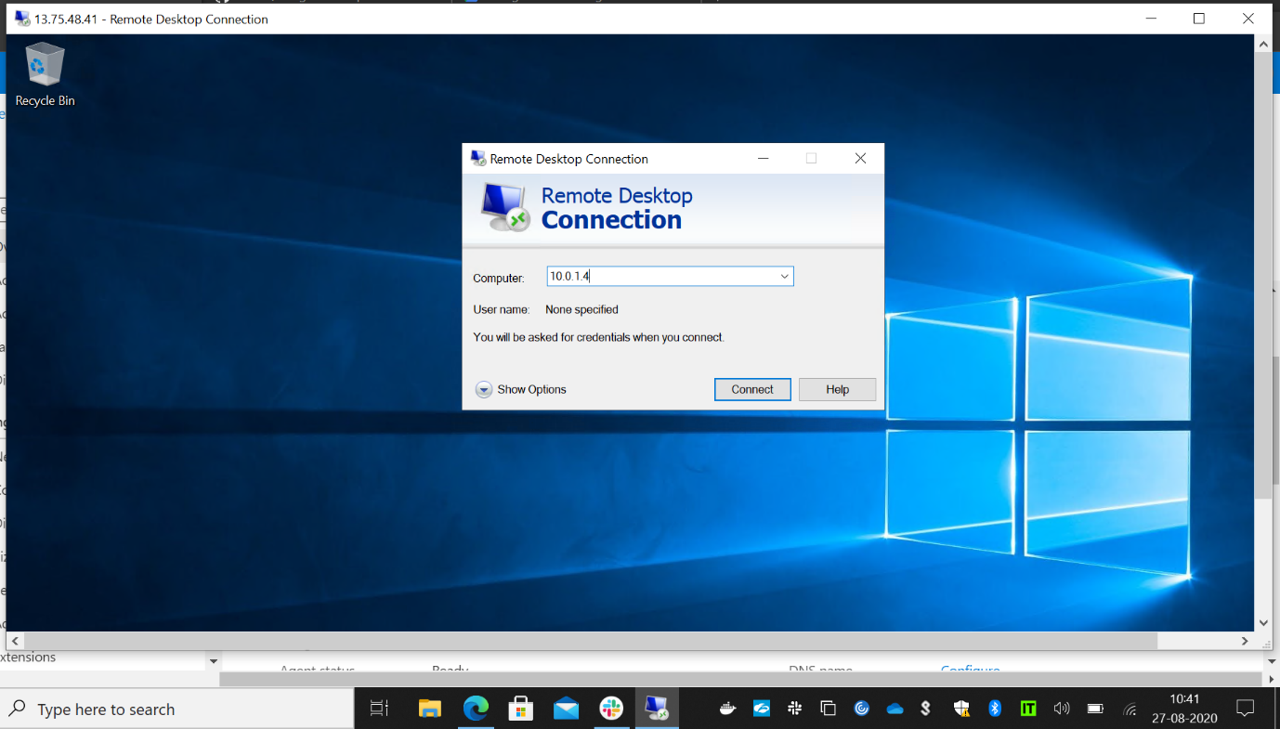

And trying to connect the vm which is another network and which is in west us by using the private ip.

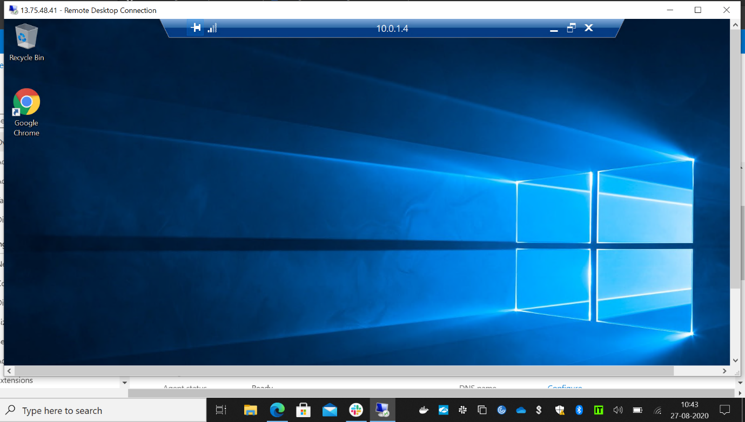

Here is the vm in another networked connected using the private ip.

3.Create a Point to site VPN in west us location and try connect from your location laptop

to Azure datacentre.

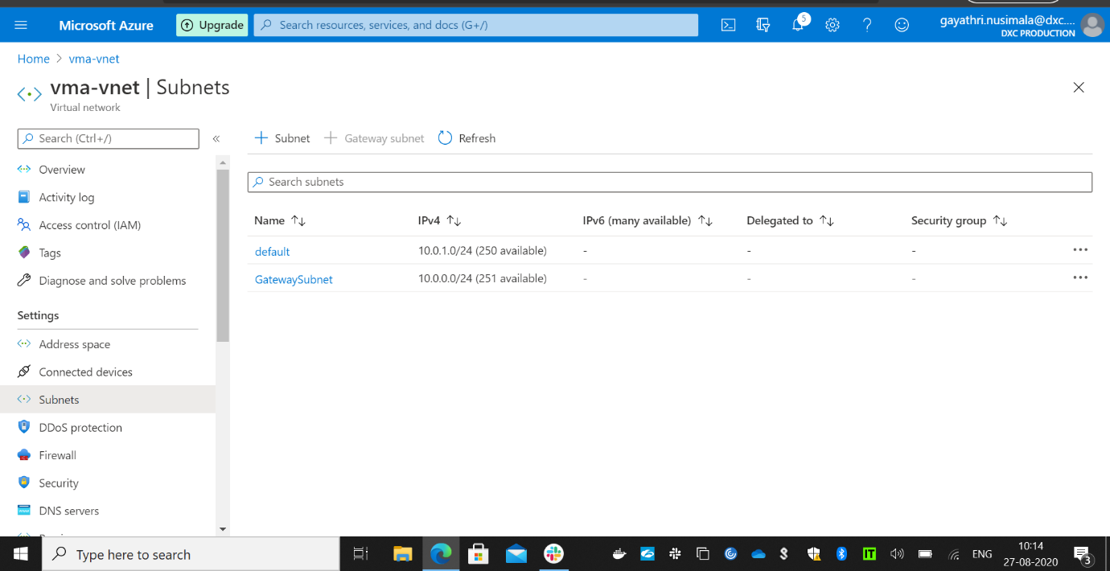

Created a gateway subnet before creating the vpn gateway.

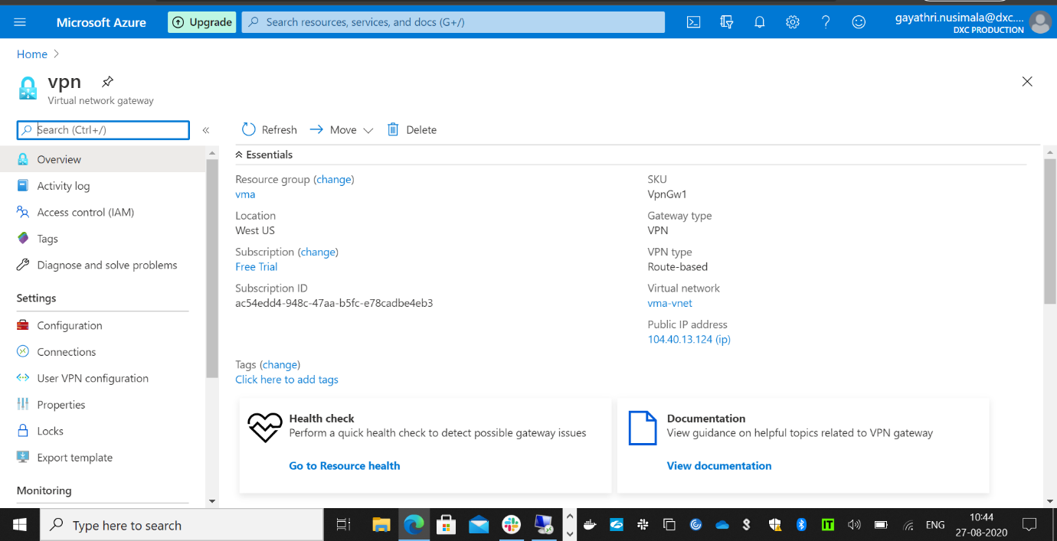

Created the vpn gateway in west us.

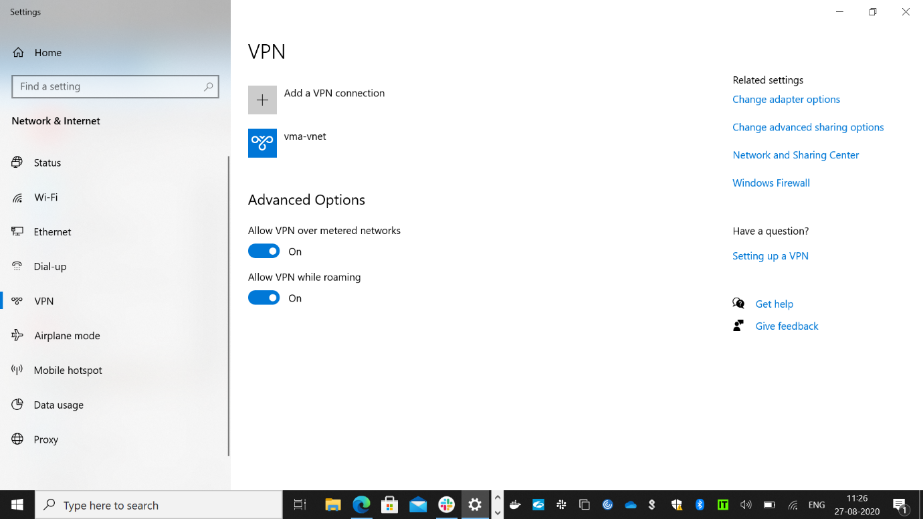

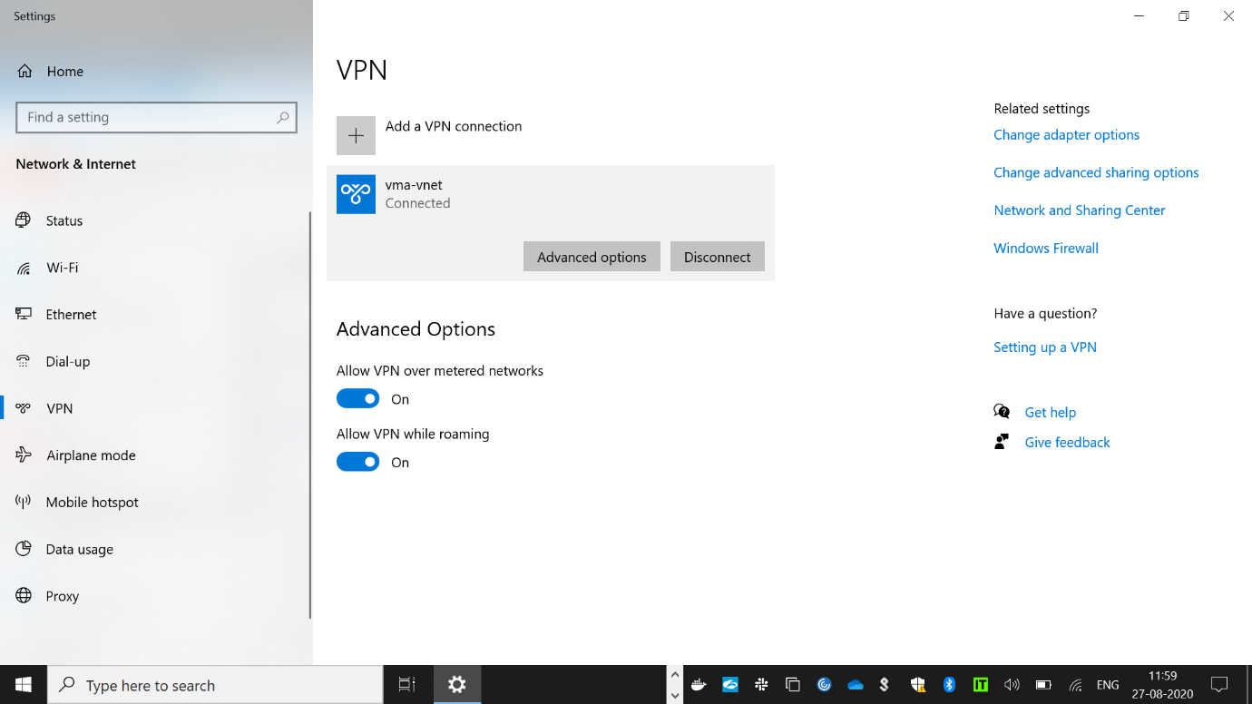

Connected the vpn .

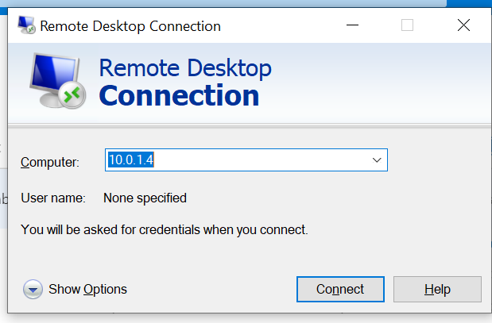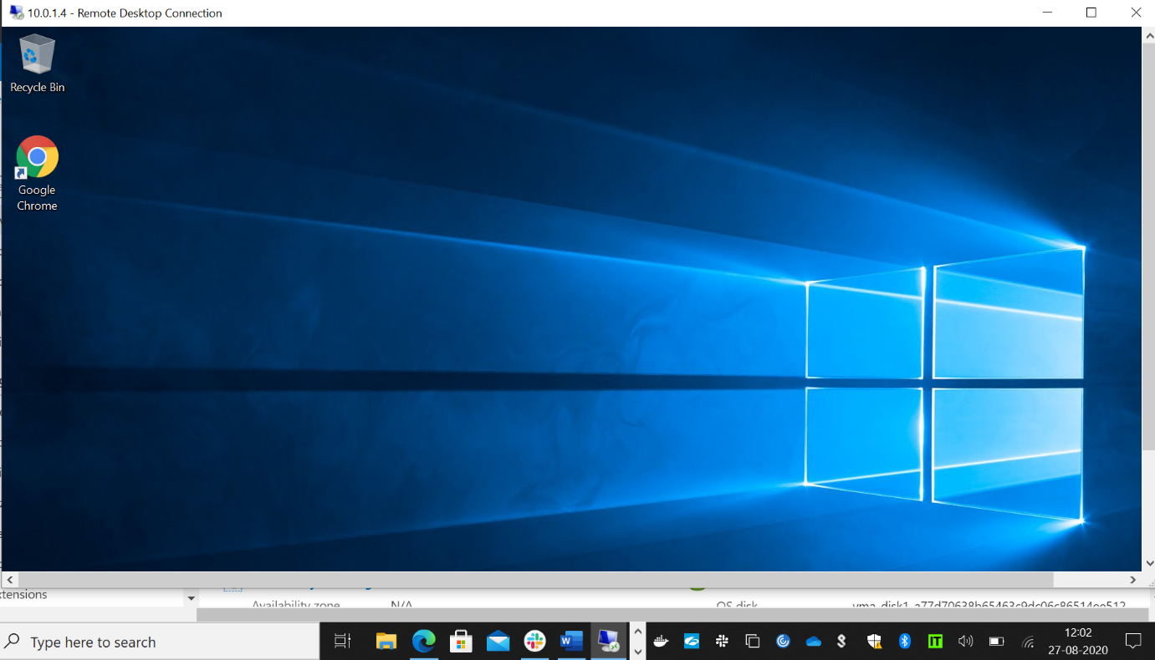

I have tried to connect to the vm with the private ip by using the vpn network it is connected without any blockers.

4. Create a two web applications and put the apps under traffic manager with Priority routing method.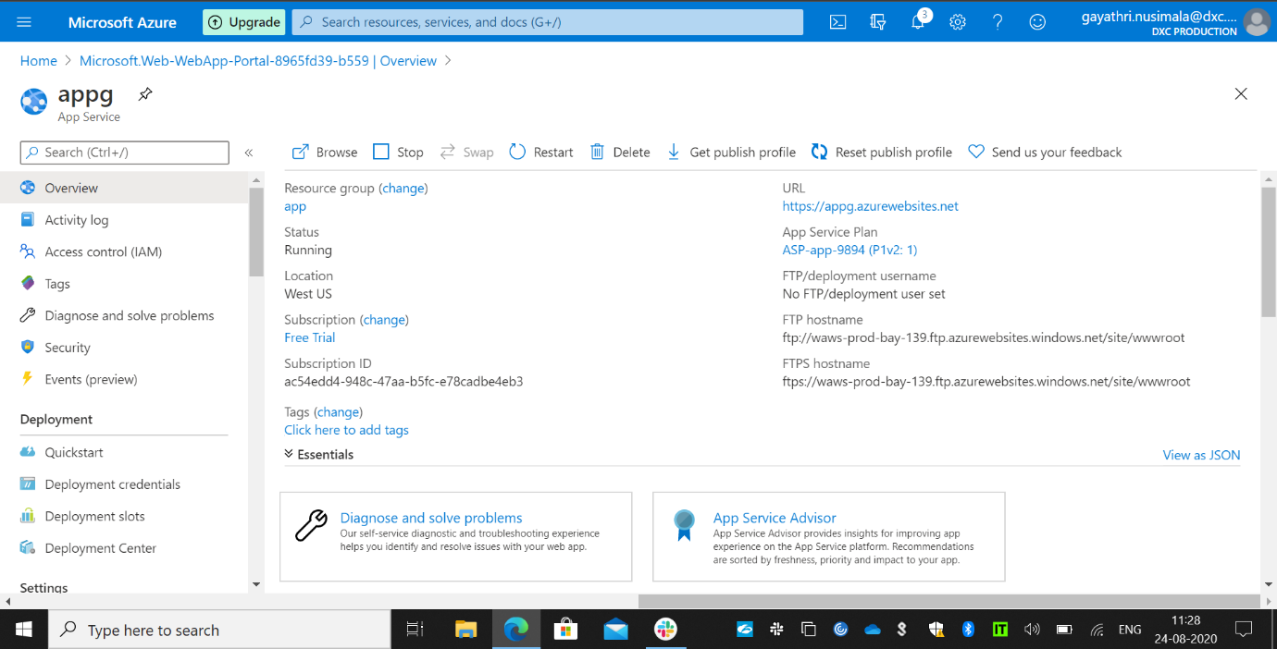

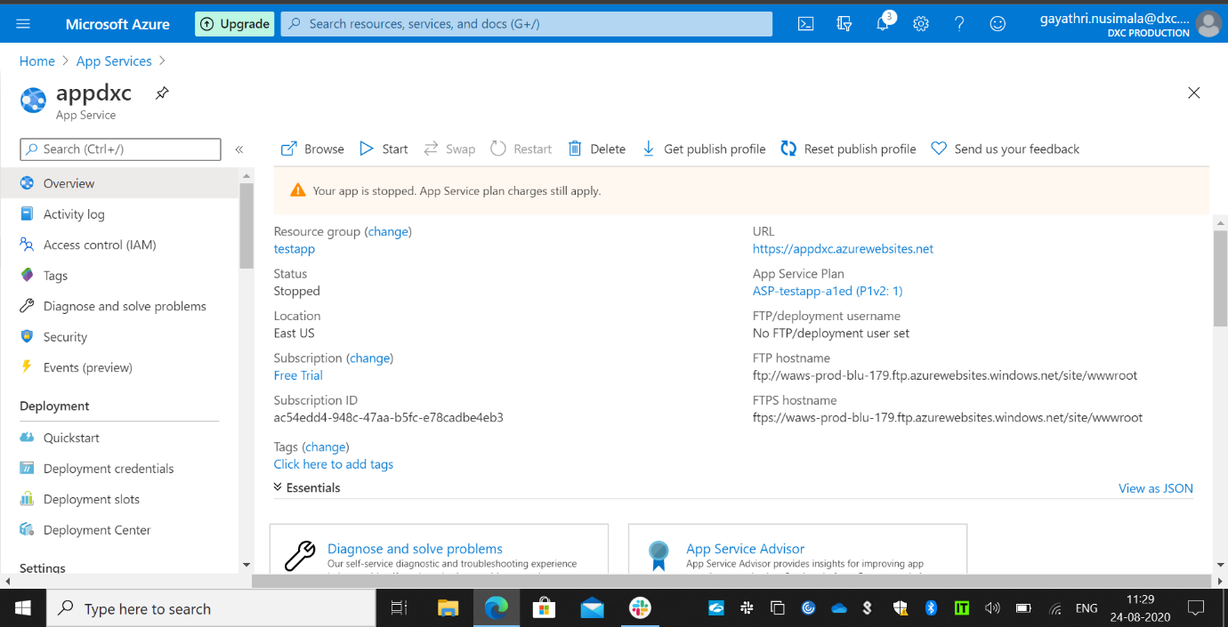

Created two web applications.

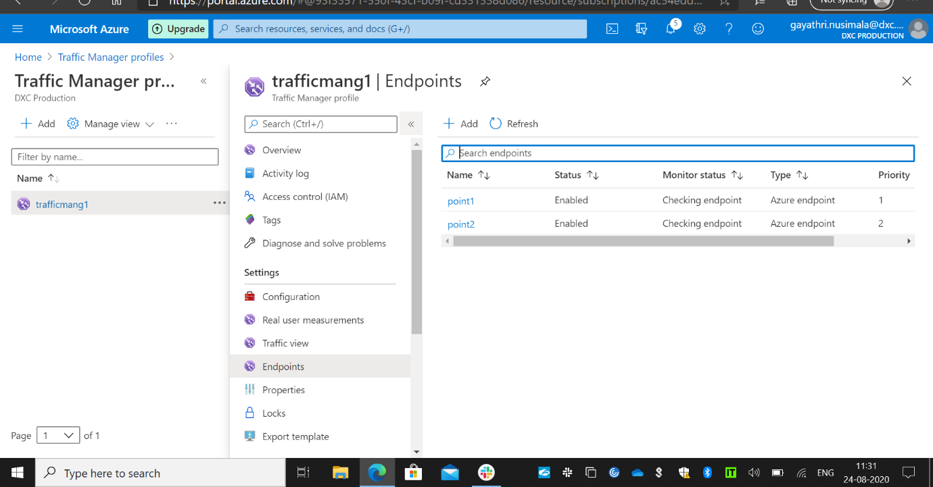

I have created a traffic manager and added the two application in the traffic manager as end points with the priority routing method.

5.Create a Backup solution for the Vm and assign a daily policy to the VM with 10 days retention period.

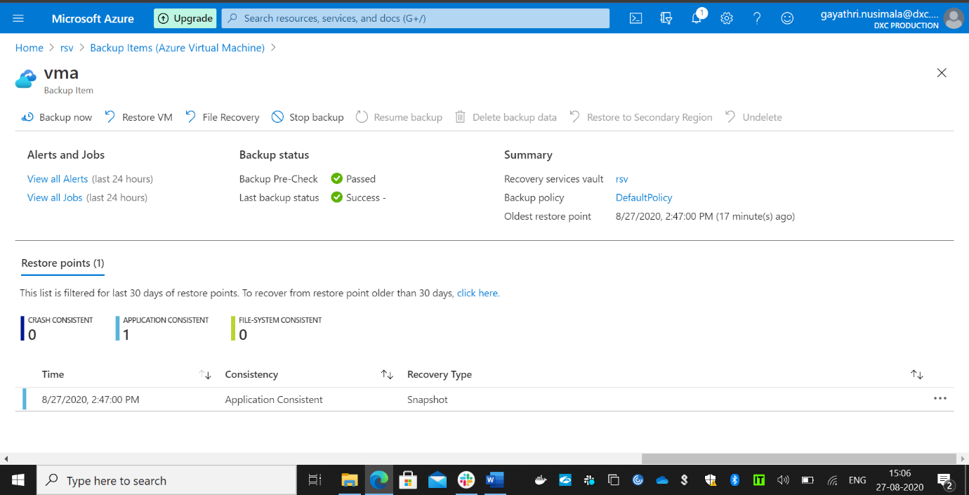

Created a backup solution for the vm.

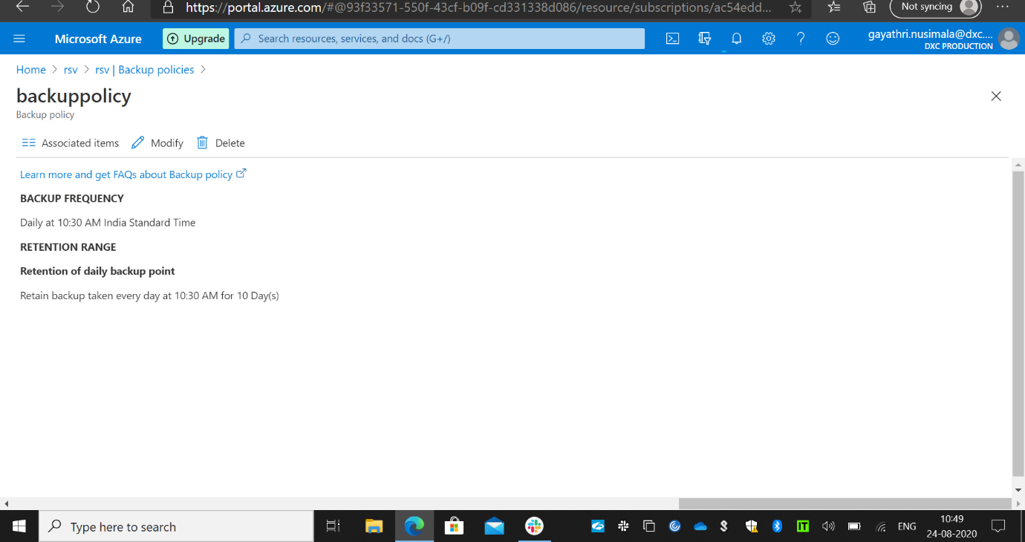

Assigned a daily policy to the vm with 10 days retention period .

6. Replicate the VM form west us to any location using failover.

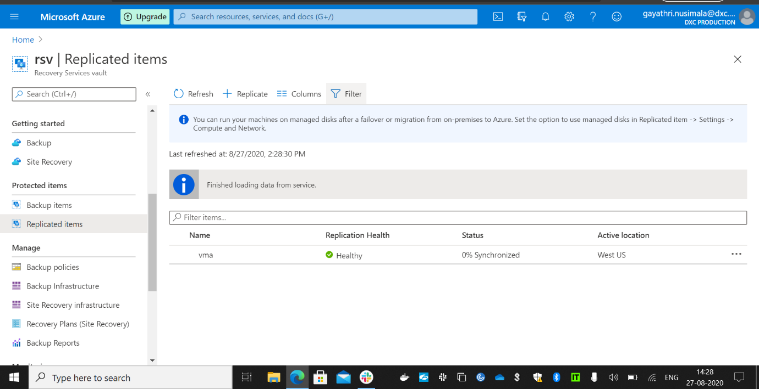

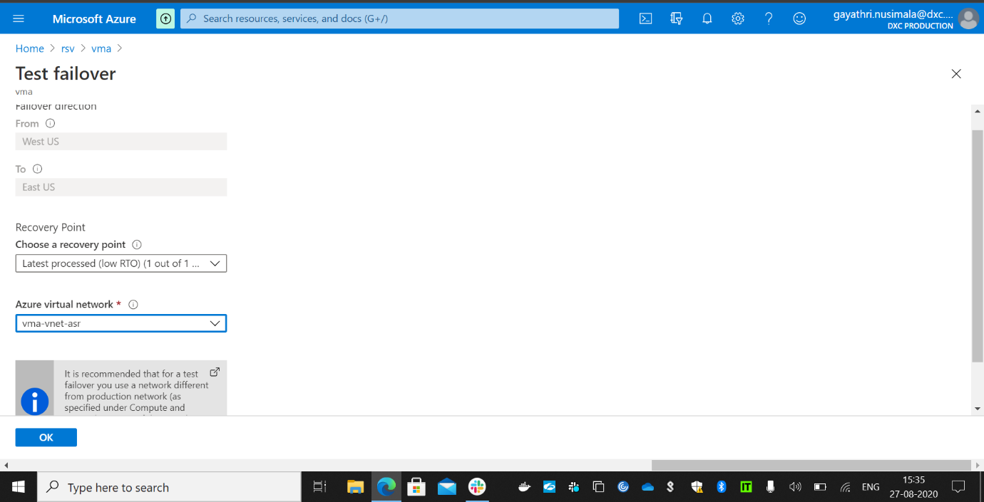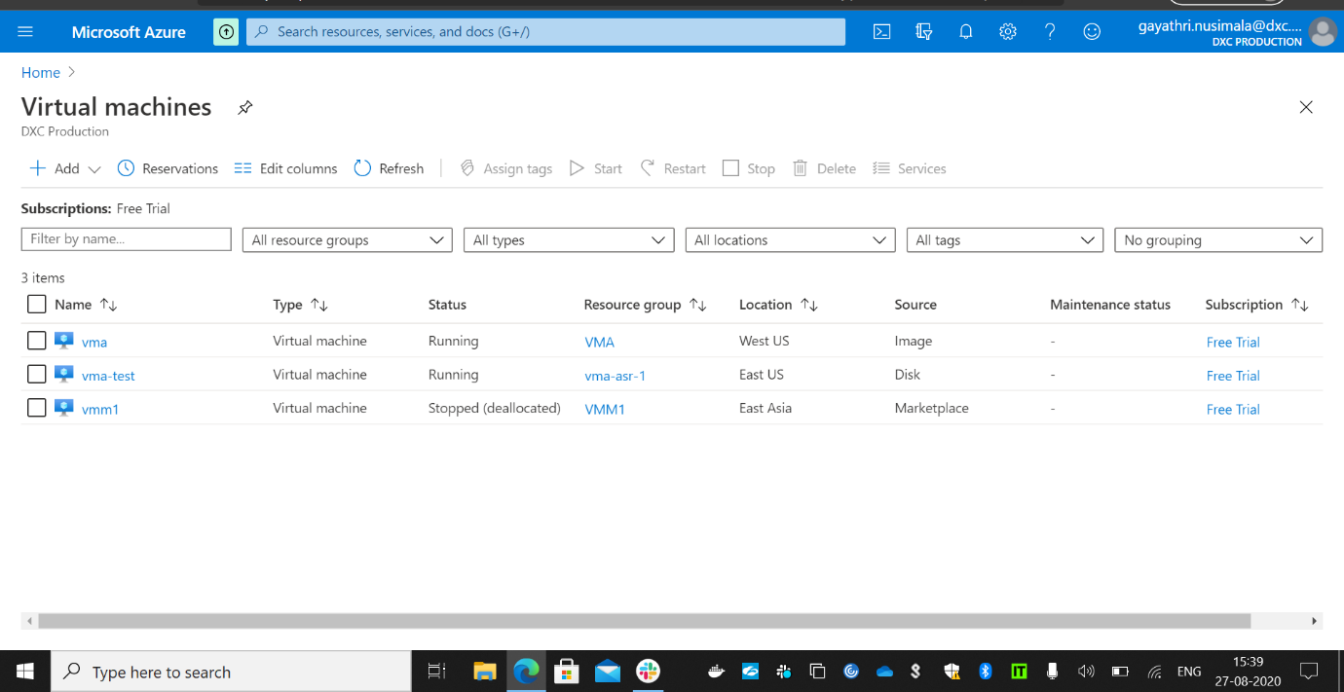

Replicated the vm from west us to east us.

7. Take a on-premises backup using backup agent and exclude test folder from any drive.

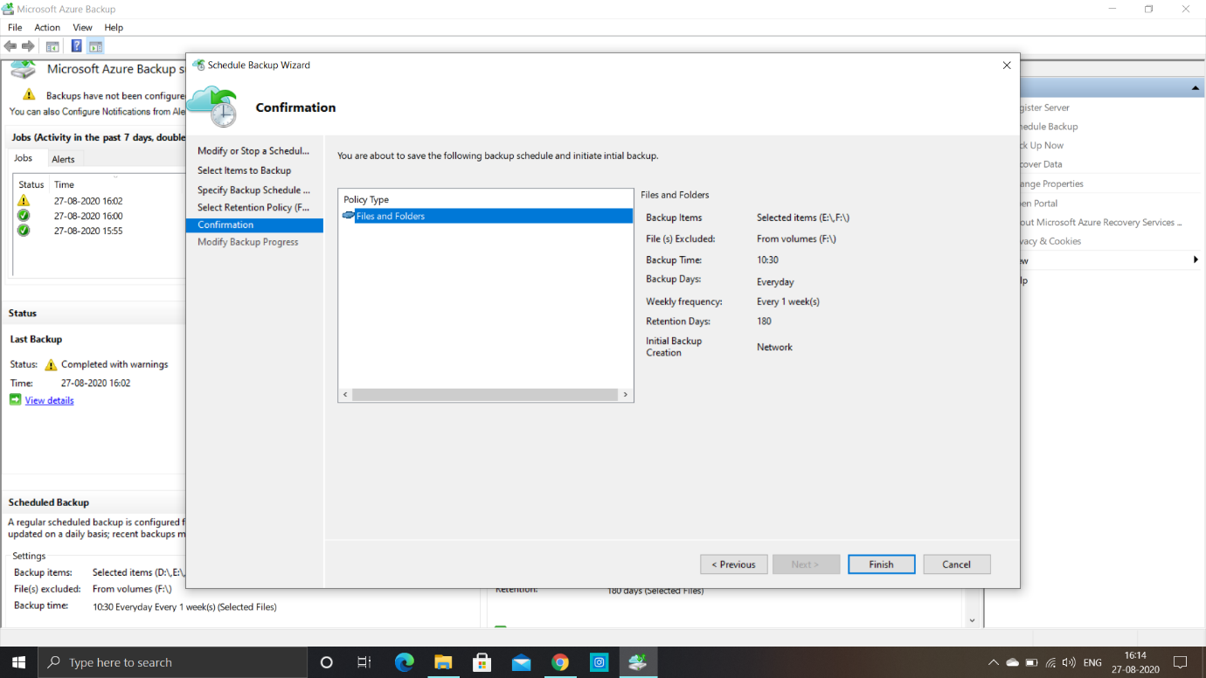

Backup scheduled for the folders E and F and excluded the folder F.

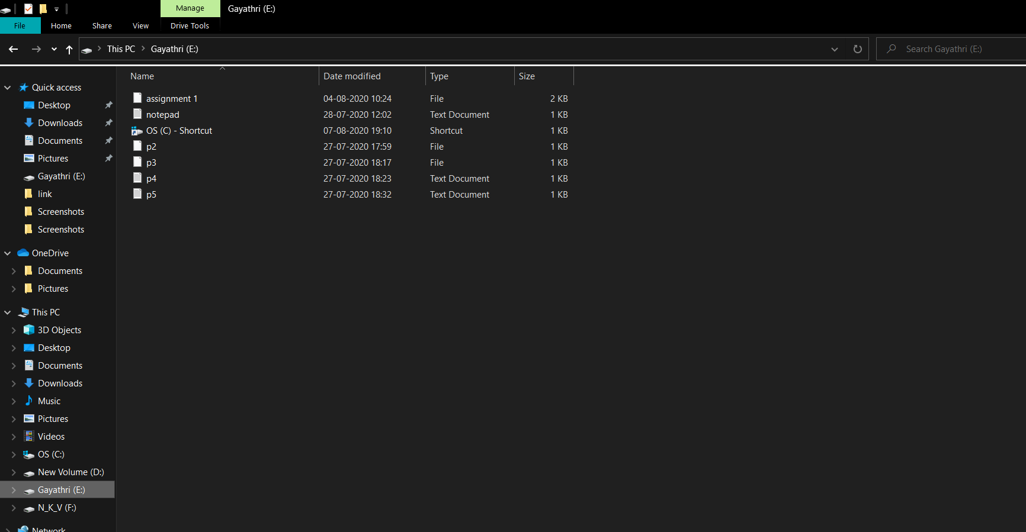

This is the folder F before deletion of items.

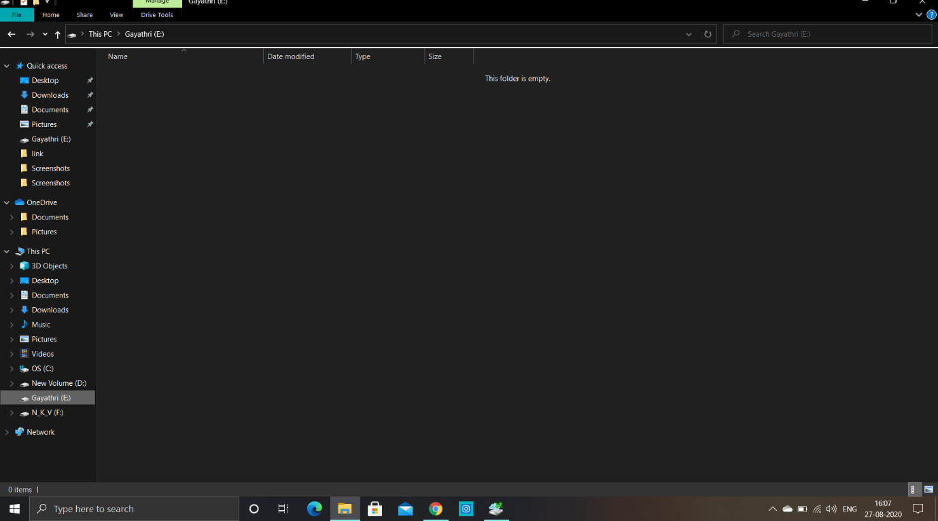

After deletion and backup we can see that the folder F files are not backuped as it is excluded from backup of files.